Alan Li

[ali59@ucsc.edu](mailto:ali59@ucsc.edu)

**Art and Animation**

This project paper is intended to inform and teach audiences about the various technical aspects of tools and advancements in the field of art and animation. It will also go into the basics of using some of these various tools. Animation has a rich history of evolution and growth; these improvements are still seen in many of today’s tools. I aim to show you how they operate and live on. I will mostly cover the more traditional 2d animations seen in many classic films and cartoons. This will also include technical aspects such as the tools and tricks that animators have used to create special effects like parallax in their works. At the end, I will give a technical guide on how to use and operate the modern day art and animation program, Procreate. The intended audience are readers who may have little to no knowledge on this particular topic and may want to learn more about it. No prior knowledge is needed to understand the content, though some may find it helpful to understand topics if one has already looked into the subject content. The chosen style guide of this paper is that of the MLA format.

**1 Introduction**

I want to preface this by saying that I am no animation or art expert, but I do have interest, some experience, and knowledge on the process of creating a piece of art. Animation and art is everywhere and has been ingrained in culture ever since its creation. It has been used as a medium for many things and that is why I am sure everyone has at least experienced or seen a piece of work in this category that has influenced their lives. In the United States, most would have grown up with Saturday morning cartoons and big motion pictures by companies such as the Walt Disney Company. It is estimated by the "Global Animation, VFX & Video Games Industry: Strategies, Trends & Opportunities” report that the United States industry has a global value of around 270 billion United States dollars. You will also see animation in many other parts of the world, one example being the massive anime industry from Japan. It just goes to show how widespread this industry is. Though it may seem like not much may have changed in terms of technical aspects in this industry, this could not be further from the truth. Animation and art is an industry that continuously pushes creators to innovate and improve.

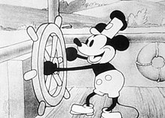

“Steamboat Willie.” *Wikipedia*, The Walt Disney Company, https://en.wikipedia.org/wiki/Mickey_Mouse.

**2 Early Inventions and How to use them**

Animations are simply a series of images manipulated or edited so that the images look like they’re moving. Though creating animations may seem like something you need a degree to do, many early animation systems were actually simple and can be made at home with little to no problem. I will now go over some of the various key advancements that were able to change and shift the field. I will also explain how to make and use the tools I will explain for the process of animation and art. As obsolete as they may be today, explaining how to use them and what they did will help you understand exactly how many of today’s tools are derived from tools of the past. Many of these were even created before the popularization of films.

**2.1 The Basics of Creating Animation**

The thaumatrope is one such invention created by W. Phillips that is considered an early version and precursor to animation. It is a relatively simple invention and is basically just a disc with an image on both of its sides. When you attach a string to both sides of the image and twirl it, the image will move back and forth creating an illusion of a motion picture. One would easily be able to emulate and create this at home by just cutting out a piece of paper and attaching a string. Below is an example of what a thaumatrope looks like.

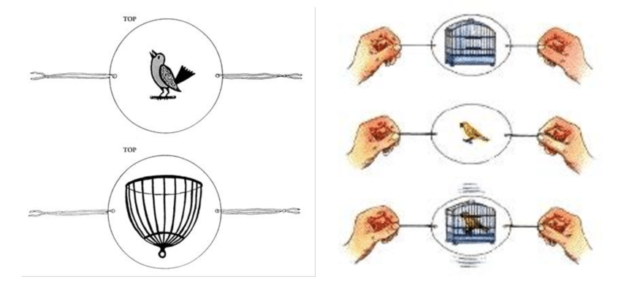

Griffiths, Carol, et al. “Thaumatrope, Illusion of Movement.” *Research Gate*, Dec. 2013, <https://www.researchgate.net/figure/Thaumatrope-Figure-2-Illusion-of-movement_fig19_259211673>.

One would also be able to emulate this by sticking a double sided image on a stick and rapidly spinning the stick. Though extremely simple, by explaining and teaching how to create one of the most basic forms of animation with the use of a thaumatrope, I hope that this may help in your understanding of animation. A series of rapidly changing images are perceived by the human eye as seamlessly moving. This is essentially what serves as the basis for what we know as animation and will be key to many of the other things that I will teach how to use.

**2.2 Creating Animations With More Than Two Frames**

Now that I have explained the basics of animation through the use of a thaumatrope and its two frames, I will now go more in depth about animation without being limited to just two single frames. Not being limited to a few frames allows for more options and flexibility when it comes to finishing a piece. It also allows for wider expression of technical elements.

**2.2.1 Frames Per Second**

The number of frames in one second of animation is very important to the smoothness and illusion of a given animation. This is often abbreviated as FPS (frames per second) by people and is the term used when describing anything on a screen that may be moving. You will hear this term thrown around quite often when on the topic of media such as video games, television, and film. The image below clearly shows the distinction between various FPS amounts. 60 FPS and 30 FPS are two very common values when it comes to media.

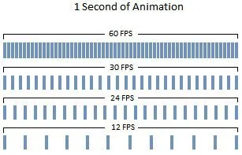

“Seconds of Animation.” *Stopmotionmagazine*, 31 Aug. 2019, https://stopmotionmagazine.com/why-your-frame-rate-fps-matters-in-animation/.

You will see most big animated films animated at around 24 frames per second. Though this is not high in regards to how much an image could be updated, this amount is enough to trick the human eye that what they are seeing is a single fluid motion rather than a slide show. Animators can also determine how many seconds one image can hold. If an animation is shot on “threes,” a drawing will be shown for every three frames hence there will be 8 unique drawings per second at 24 frames per second. An animation shot on “ones” will have 24 unique drawings per second. The most common standard for animation to be created and shot on are in “twos” though animators will also change this when needed to more easily convey a different sense of motion. (Chew) This is important as this is the standard and basis that the animation industry has held and followed for years.

**2.2.2 Creating and And Experiencing More Than Two Frames**

To experience more than two frames of animation or motion, tons of new inventions were created soon after the thaumatrope. These inventions all consisted of having multiple images moving at high speeds to create the illusion of animation. Such inventions include the Phénakisticope, Zoetrope, Kineograph, Praxinoscope, and the Zoopraxiscope. Of the bunch, the one an individual may most easily be able to make is the kineograph. As intimidating or foreign as the name may sound, this is quite simply just a flip book. A flip book is essentially a book filled with images that make up one complete animation. By having a book with its pages filled with images, you can emulate an animation by flipping through it quickly with your fingers. The number of images the flip book has is totally up to the creator. It is not limited like the thaumatrope I described earlier. It should be mentioned that flip book is also different from a normal book in the sense that you are not flipping every page manually. You instead flip through the pages with your thumbs against the edge of the page; this will allow you to flip at a rate such that the illusion of motion is created. Each image on a page represents one frame and the images from one page to the next page should indicate some sort of movement or transition.

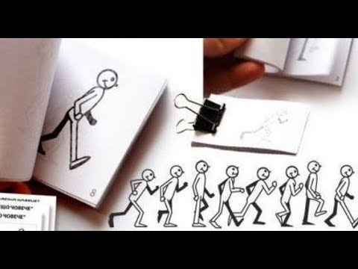

Deyo. “Flipbook.” *Mrdeyo-WMS Art & Education* , <https://mrdeyo.com/flipbooks/>.

In the image above is a given example of what the pages of a flip book could look like. In this case, we are animating a person walking. It will first begin with a man in standing position and then the page after that will feature a picture of the man taking the next step in his walk. By stringing all these images together, we will end up with one smooth completed animation. I hoped this helped further your understanding of exactly how animation works. It is a simple process, but the work put into drawing the frames can be time consuming. There are of course some time and work saving techniques such as the holding a frame technique I discussed earlier and I will go a bit more into them.

**2.3 Shortcuts For Use**

As much fun as animation and drawing may seem, it can actually be very taxing and tedious when creating longer length pieces. As a result, there are many cheats and shortcuts one can take to ease the amount of work needed to be done. This can range from many things, but oftentimes the viewers will not even notice these techniques unless they are looking very closely.

**2.3.1 Reusing Shots**

It is not rare for shots to be reused in the animation industry. One may easily be able to reuse shots simply by shifting the image the camera sees. The most basic example just requires the animator to zoom in and out of the subjects in the shot when showing something such as dialogue between two characters. “The idea is simple: Animate a five-second clip, interject a closeup, cut back to the first shot again with new dialogue. Repeat until the end of exposition.” (Kenlon) This saves time and effort since animators are able to extend the usage they can get out of one drawing.

Reusing shots can also mean that animators go back and use frames and shots that have been used previously in different works. This is actually a common strategy that Disney used to save money when developing animated films. (Coffey)

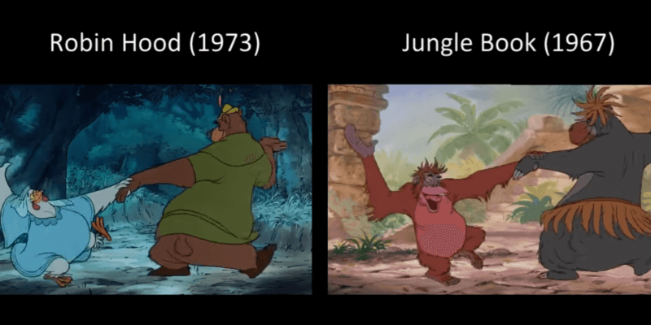

Coffey, Kelly. “‘Robin Hood’ vs. ‘Jungle Book.’” *Inside the Magic*, 20 Sept. 2019, https://insidethemagic.net/2019/09/does-disney-recycle-animation-drawings-kc1/.

Above is an image from the films, Robin Hood from 1973 and Jungle Book from 1967. Looking at the two side by side, one would easily be able to tell that they are the same frames, but detailed and painted differently. The underlying motion and subjects are the same, but everything from the color to the background can be changed. One may notice this upon multiple viewings of animations; but on first view, I would argue that it would be challenging for anyone to notice instantly that a shot was reused and from where it was taken.

**2.3.2 Looping the Background**

Backgrounds can be tough to do in animation. If a character were traveling on the screen, would you draw a new background every time the frame changes? There is actually a smart way you can do backgrounds by looping background images. You may notice this in a lot of older animations where a character moves from left to right on the screen. An example would be if a character was moving left to right in a city; you might see the same series of buildings multiple times as the character moves. That is because the animators are moving the background left to right and once it hits the end, they are resetting the background back to the beginning on the left side of the frame. In general, this works because most of the viewer’s attendance should be focused on the moving main subject of the shot rather than the background. (Kenlon)

**2.3.3 Solution for Hard to Animate Actions**

Motions and actions can be hard to animate when it comes to drawing the frames out. That is why animators will often rely on the following technique to entirely skip out on that process. The workaround essentially sets up the action and then cuts away to a shot of a character watching the action and how he reacts to what is happening. The action is now happening offscreen, but the character’s reaction implies to the viewer that something actually did happen. You can also reinforce this shot by showing the aftermath of the action after the character’s reaction with just one shot. You can see that instead of animating one whole process, you could get away with just showing the set up and the ending of the action. (Kenlon)

**3.1 Using more Layers**

Up until now, I have just been speaking about animation in terms of one or two layers. Essentially what I mean by one layer is that every frame is drawn on one layer so that the background and characters are on the same plane. If it were two layers, the characters would be on a layer above a background layer. Layers can be implemented using cel sheets or more simply transparent sheets. The bottom most layer is always the drawn background and the sheets above it are most often just the characters drawn on transparent sheets. If it were not for this, you would have to draw the background all over again for every frame. In this case, the background acts similarly to a stage for a play. The stage does not change often, so it is up to the characters to move and maneuver around it. The usage and implementation of using more layers has become more common over time and is still present in many of today’s art programs.

**3.2 The Multiplane Camera**

The multiplane camera is one invention that took advantage and popularized the use of having more than one layer in animation. It was invented by Ub Iwerks at Walt Disney Studios in 1933 and was used for many films. (Walt Disney Multiplane Educator Guide) The name is self-explanatory and the machine essentially operates by making the most out of a shot containing more than one plane or layer. One may be able to build their own at home using a simple rack, any form of transparent sheets, and a spare camera.

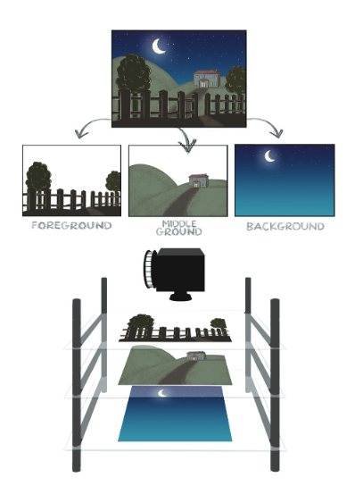 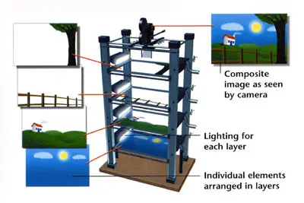

“Multiplane Camera.” *Animationschooldaily*, <https://animationschooldaily.com/multiplane-cameras/>.

“Multiplane Camera Set Up.” *Walt Disney*, https://www.waltdisney.org/sites/default/files/MultiplaneGuideCurriculumPacket_Final.pdf.

In general, the structure of a multiplane camera consists of a camera at the top of the structure followed by layers of each frame layered level by level vertically below it. The layers are also able to be manipulated and shifted further and closer during the production in order to enhance the realism and quality of certain shots. Each plane is typically glass and can be moved by something such as a hand crank. They can be accompanied by light on each layer as well to help with the ambience of a shot. Once every aspect is lined up perfectly, the camera operator at the top will inform the people operating the machine at the bottom and take a shot of the layers. In the end, this will become one frame for the animation.

**3.2.1 Effects and Upsides of Having Multiple Layers**

The implementation of having multiple layers really allows for a lot of creative freedom. Just like I stated early on, it allows for the creation of effects such as parallaxing which is the illusion of depth in a two-dimensional image. This can be done by moving the various layers of the multiplane camera at different speeds. In real life, objects further away take longer to move across your line of sight so the bottommost layer moves the slowest. In contrast, the topmost layer should move across the camera the fastest as it is the biggest and the closest to one’s eye. In addition, you can also move the foreground and background layers in opposite directions to create a rotation effect as evident in Walt Disney’s Snow White film. Before this camera, it would have been difficult to do shots in which the camera followed and moved alongside the subject.

**3.2.2 Digitization of the Layering System**

Eventually though, as animation and technology grew, new tools were able to be used such as the personal computer. The popularization and growth of the personal computer allowed the animation industry to almost completely digitize the animation process. At Disney, the multiplane camera was replaced by the CAPS (Computer Animation Production System) process which could easily do what the multiplane camera did with less effort. (CAPS: Executive Summary) Past traditional art techniques and methods were also converted into that of a computerized one. The list includes painting, inking, and adding special camera effects. CAPS is very reminiscent of the programs such as photoshop and procreate that we use today to create art. It allowed artists to scan their images into the computer and continue their work on there. Due to the computer not having size limitations for artwork, animators were also able to create new camera movements. Along with that, entirely new tools were offered as well.

**3.2.3 3d Elements and The Future**

Animation studios were no longer limited by traditional 2d elements. They were now able to implement 3d objects into their works. The first example used by Disney is in the film, Beauty and The Beast, in which the two main characters drawn in 2d are filmed dancing around a 3d computer generated ballroom. The 2d images would be considered its own layers and then put on top of the 3d images. Though this type of hybrid animation is a bit rare today, this introduction of 3d animation led the way for what we commonly see in films today. 2d animations are no longer as prominent as they were in the past. Films will typically feature 3d CG animation. In technical aspects, 3CG animation has advanced to the point where results are much more time saving and profitable than the former.

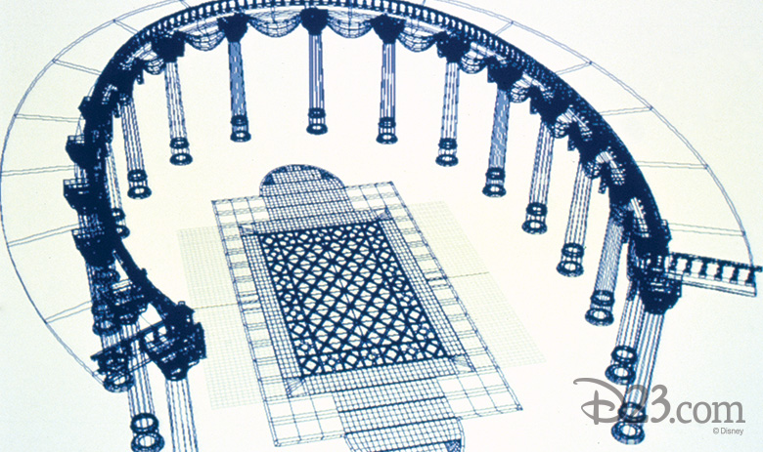

Rannie, Alexander. “Beauty and the Beast Ballroom 3d CG.” *d23*, 30 Sept. 2016, https://d23.com/ever-a-surprise-the-history-and-the-magic-behind-the-ballroom-in-beauty-and-the-beast/.

Unlike 2d animation, resources can more easily be reused. The models created for a piece can easily be remolded and retextured. Camera shots can also be modified and edited more conveniently now. In traditional animation, it takes a lot of time and effort to change elements like the camera angle or lighting; you’d have to draw everything again. With 3d animation, everything is a 3d object in a 3d world sculpted on a computer. Changing camera angle or lighting just takes a single click. Generally, it is easier and cheaper to go back and fix things in 3d cg, but more expensive than 2d animation initially. Movies that feature computer generated images can be considered animation. You might recall the most recent remake of The Lion King in which the original animated piece was completely remade. The film was labeled live action, but in reality a lot of the assets in the film were modeled and created by animators. It just goes to show you how far animation has come since its early days as short black and white cartoons with no sound.

**4.1 Current Programs**

Nowadays, anyone can get into animation. You do not need much to begin. There are a large number of programs. A few reputable ones would be Unity, Maya, and Blender for 3d animation and Photoshop, Toon Boom Harmony, and Procreate for 2d animation. I personally use Procreate for all my 2d drawing and animation needs, but you may choose whichever one best suits your needs.

**4.2 How to use Procreate**

Procreate is an application available on the iOS app store. This app is simple and lightweight, but still offers a lot of the tools available on a more heavy-duty application such as photoshop. The user interface is also very user friendly so I highly recommend this application for beginners who may want to get into art or animation. It is also one of the cheapest applications of the bunch.

To begin use, begin by selecting a canvas size via the plus button on the top right corner of the application. You will be able to select preset sizes or input your own custom sizes for the canvas. One thing that an individual should keep in mind is that the larger the canvas size, the less layers you can use. This is one limitation of this application. Other applications and devices may have different limitations. For example, an industry animator may have a powerful computer to be able to handle more demanding workloads.

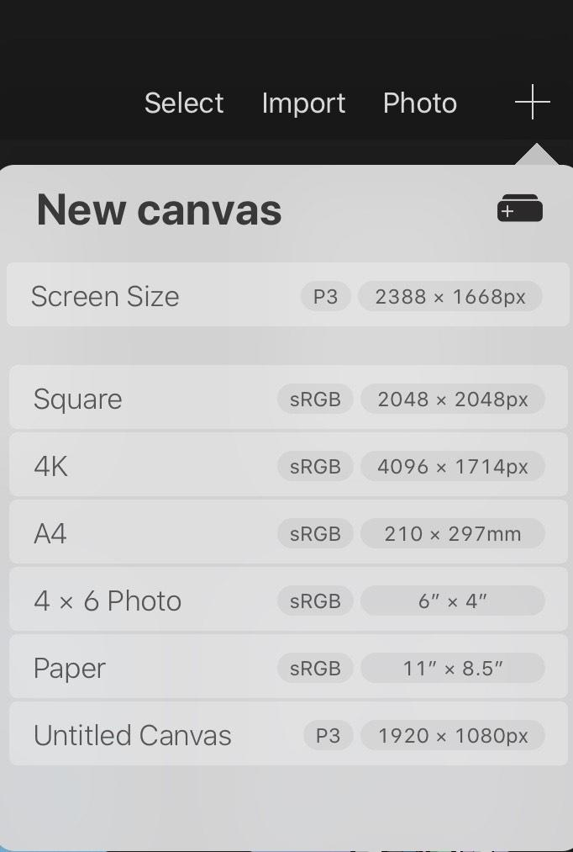 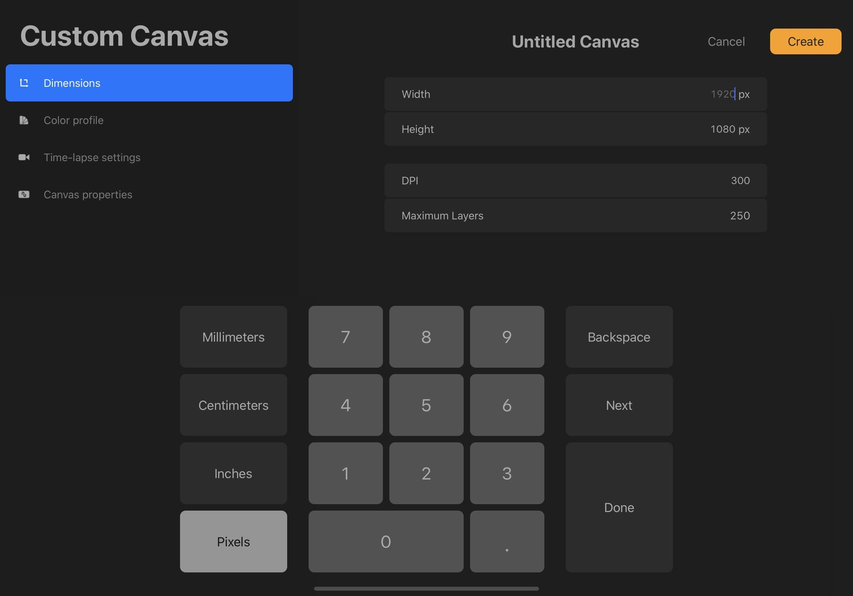

The layers here should work the same way as layers from other applications similar to the multiple camera and CAPS. You will have the option to rearrange, remove, and edit layers as you would in real life with a multiplane camera. Access to the layers options are located at the top right of the user interface.

Additionally, you are offered layer modes, a more recent tool of modern-day programs. What they do is change the way a certain layer will blend with other layers. For example, the multiply layer mode will multiply the color of the blending layer by the base layers underneath. Once you have a layer, you can begin drawing with brushes and tools.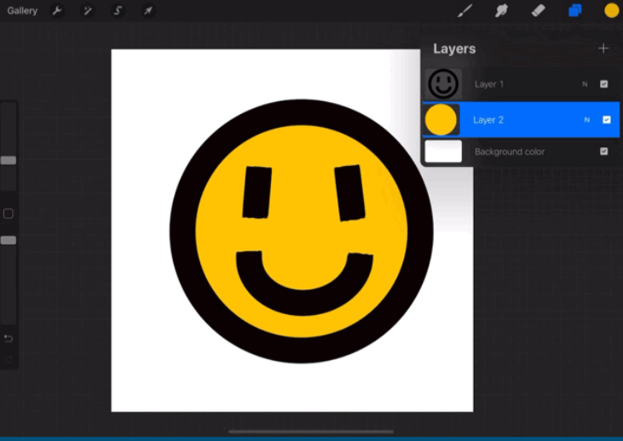

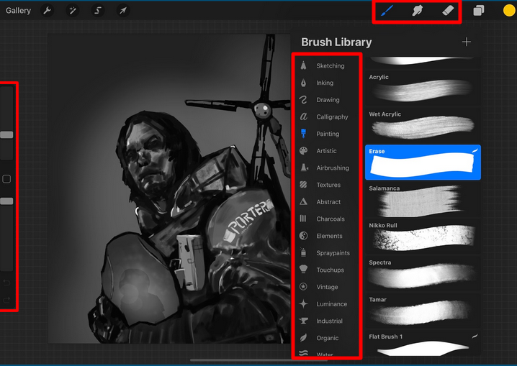

The brushes and tools section can be accessed via the leftmost icons on the top right corner. From left to right, they are the brush tool, smudge tool, eraser tool. Smudge and eraser and pretty self-explanatory, but the brush tools offer you a wide variety of options. On the left, the sliders represent the size and the opacity of the current brush. Changing the top slider will change the size, and changing the bottom will affect the opacity (transparency). There is also an undo arrow and redo arrow there for your convenience. To change the color, simply tap the colored circle on the top right.

Each brush contains a certain pattern, spread, and sensitivity pressure curve as well. The pattern determines how the brush tip is. The pressure curve determines how much or little the stylus pressure you put will affect the brush. This is similar to real life where if you press harder with a crayon, you will get a darker and bigger stroke and the opposite if you press lightly. Different styluses offer different pressure sensitivity caps, so some may not be able to emulate a real brush or pen too well. Higher sensitivity cap means there is a wider range of pressure the stylus can recognize hence a more accurate drawing experience.

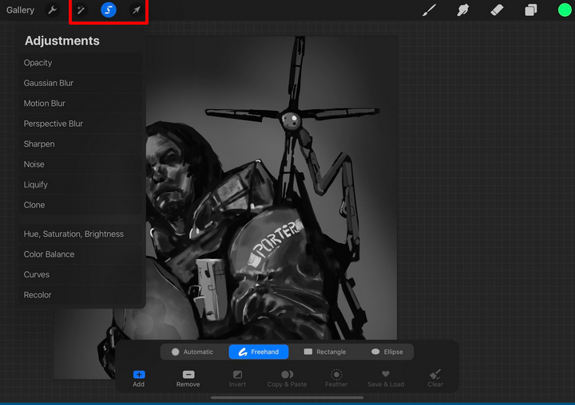

The final basic things you need to know are the selections and adjustment settings in the red section I highlighted above. The magic wand looking icon is for adjustments which allows you to modify a selected area of your art piece according to the effect that you select. The S icon is for selecting parts of your artwork. It will bring up a menu bar at the bottom and you will be able to choose the method of selection. Selection can oftentimes be used for adjustments like I just said or to move that part of the drawing if you have the mouse cursor icon selected.

**4.3 Creating Art**

Now that I have described the basics of procreate, I will explain one simplified basic way of going about creating an art piece. There are many ways to go about drawing, but this is the one that proves to be most linear and easy to understand for both beginning and experienced artists. You will want to begin most drawings with a simple sketch. The purpose of this is to lay out the basic idea or concepts and then build off of this later. Some useful tools here would include the pencil brush tool and lowering the transparency of the brush to make your lines lighter.

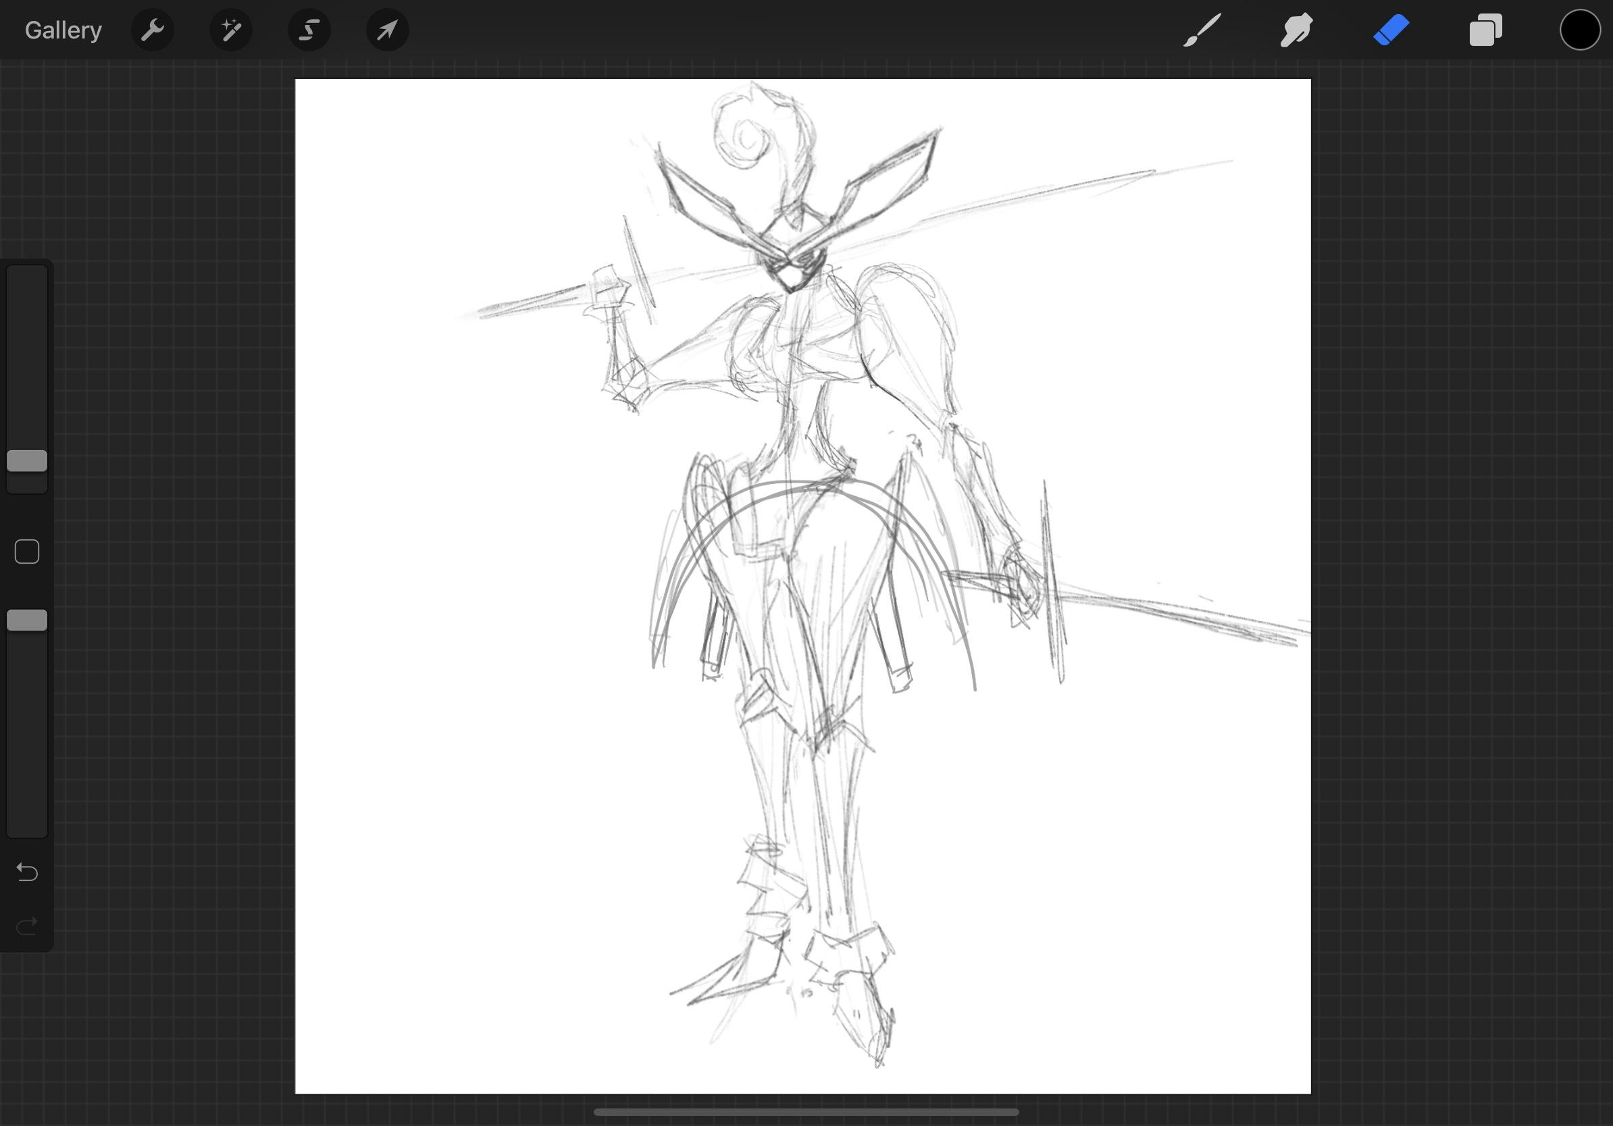

With the basic sketch, you can move on to the next step which is to draw the basic line art over the sketch. The line art should be done on top of the sketch layer with a dark solid brush. This is to ensure that your lines are clear and readable. The purpose of doing this on another layer is so that you can hide the sketch layer after you’re done. This line art will be what pulls your piece together so try to put more time into making sure the lines are clean. This is oftentimes one of the most time-consuming parts. Artists commonly find themselves repeatedly undoing line strokes during this step until they get it perfect.

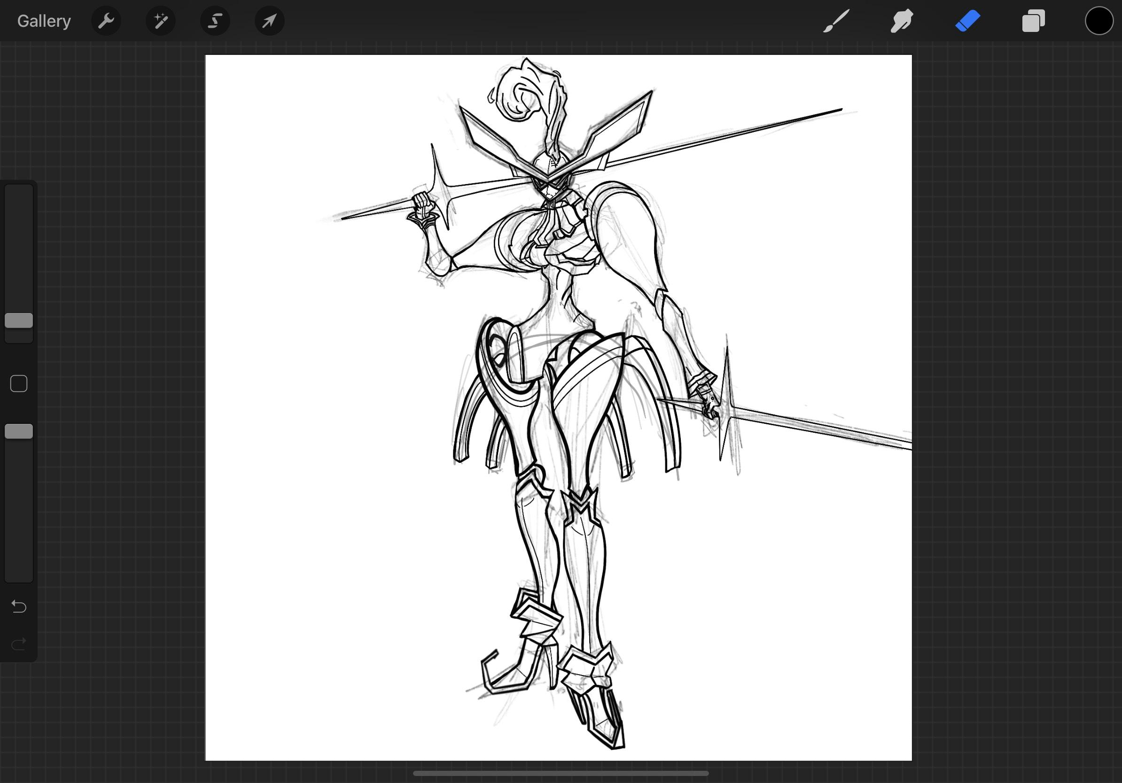

After you have finished the line art, you can now hide the sketch layer and create a new layer under the line art for colors so that it doesn’t cover the line art. In this step, you are able to test and experiment with whatever colors you’d like. This step is intended for base colors only so don’t worry about the shadows or details until after this. Feel free to use the color picker however you’d like to layout the colors of your drawing. To easily fill in colors, you can use the selection tool to select the areas between the lines and simply fill it in. This ensures that you won’t paint beyond the lines.

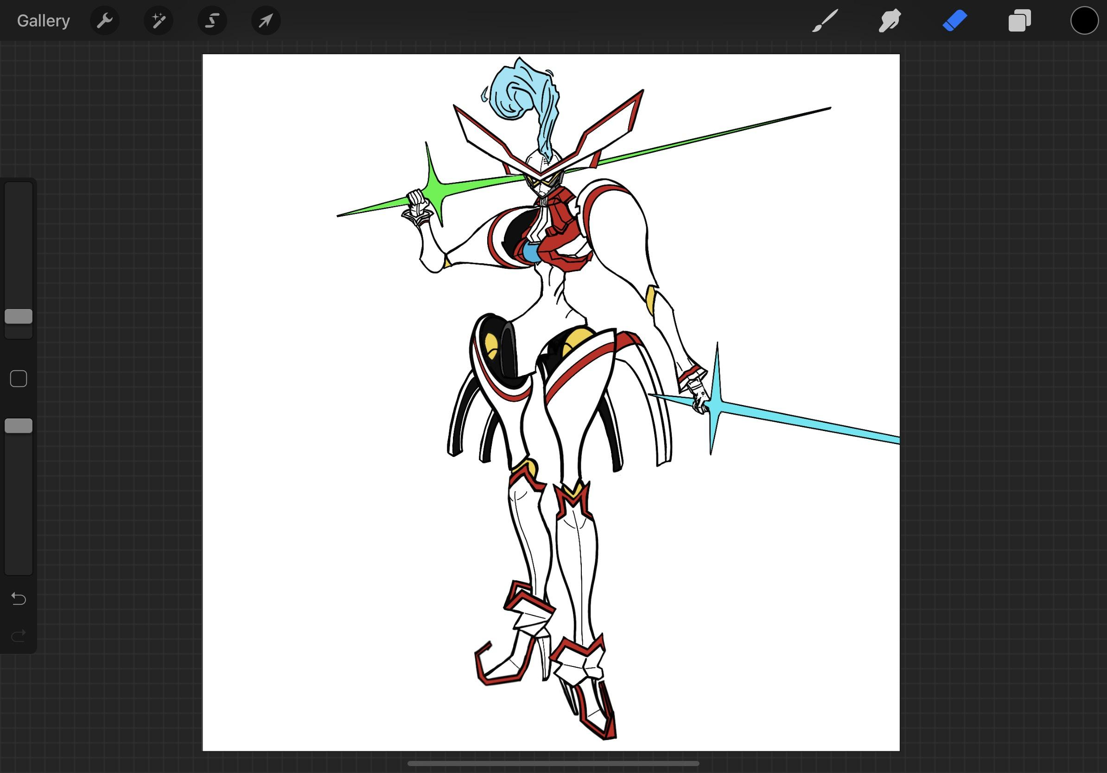

When done with the base colors, you can now add the shadows, highlights, and details. This will be done on a layer between the line art and the colors so that it will be on top of the base colors and it won’t cover the line art. Layer modes can be used here to simplify your work; the multiply layer mode is good for shadows as it multiplies the colors of your layers. You are able to use the adjustments and selection tools here as well to further select and enhance certain parts of your piece. And that’s it; you have a piece of art. As you may have been able to tell, Procreate is very much built from the foundation of previous advancements such as CAPS and the multiplane camera.

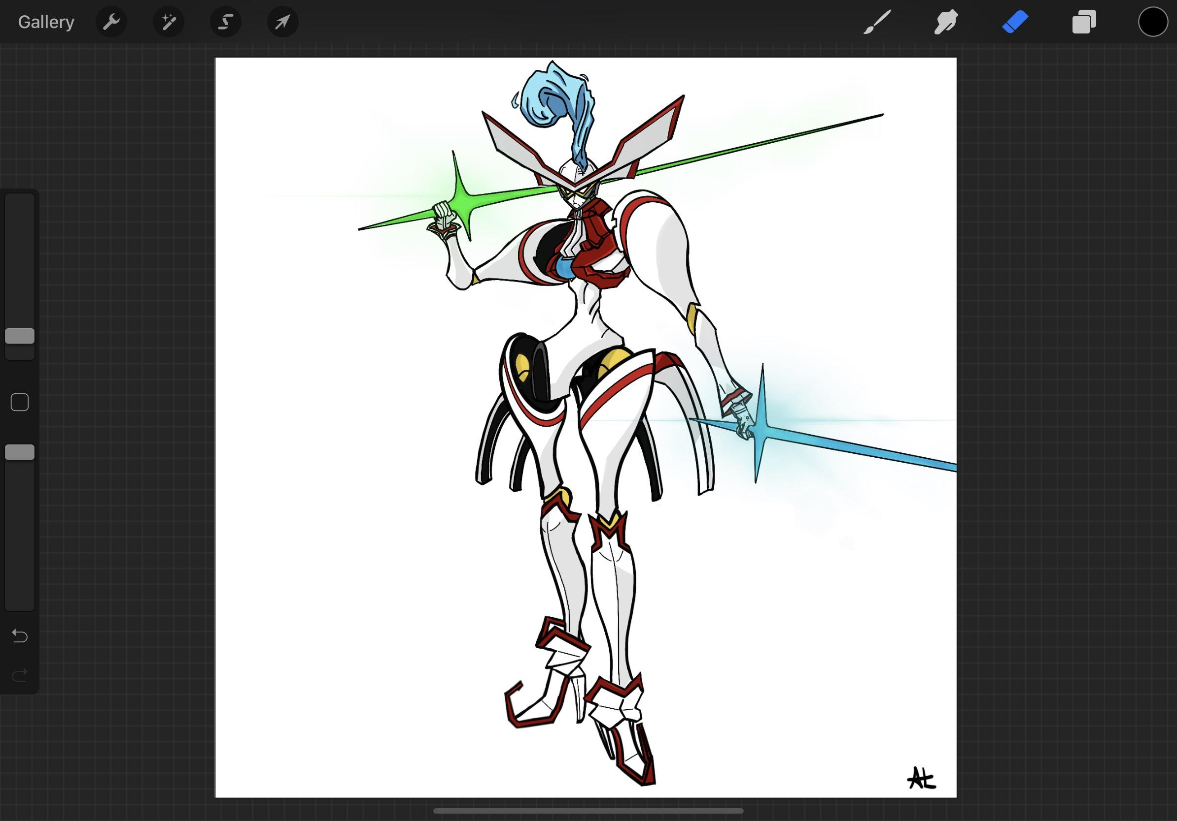

**Conclusion**

This field of work will of course continue to grow and evolve just as it has for the past, but I hope this project served its purpose of teaching you the basic technicalities of elements in Art and Animation. By transitioning from old tools and how to use them to more modern tools and solutions, I aimed to show a big picture of just how much the scene has changed. There are no strict correct rules in art but in understanding the basics, one may more easily dive into this subject even if it is just creating one simple picture at first.

**Works Cited**

“Multiplane Camera.” *Animationschooldaily*, https://animationschooldaily.com/multiplane-cameras/.

Coffey, Kelly. “‘Robin Hood’ vs. ‘Jungle Book.’” *Inside the Magic*, 20 Sept. 2019, https://insidethemagic.net/2019/09/does-disney-recycle-animation-drawings-kc1/.

Deyo. “Flipbook.” *Mrdeyo-WMS Art & Education* , https://mrdeyo.com/flipbooks/.

Griffiths, Carol, et al. “Thaumatrope, Illusion of Movement.” *Research Gate*, Dec. 2013, <https://www.researchgate.net/figure/Thaumatrope-Figure-2-Illusion-of-movement_fig19_259211673>.

*CAPS Executive Summary*. alvyray.com/Pixar/documents/CAPS_ExecSummary_AlvyToPixar_4May86.pdf.

“History of Animation.” *Wikipedia*, Wikimedia Foundation, 21 May 2020, en.wikipedia.org/wiki/History_of_animation.

“Multiplane Camera.” *Waltdisney*, https://www.waltdisney.org/sites/default/files/MultiplaneGuideCurriculumPacket_Final.pdf.

Rannie, Alexander. “Beauty and the Beast Ballroom 3d CG.” *d23*, 30 Sept. 2016, https://d23.com/ever-a-surprise-the-history-and-the-magic-behind-the-ballroom-in-beauty-and-the-beast/.

“Steamboat Willie.” *Wikipedia*, The Walt Disney Company, https://en.wikipedia.org/wiki/Mickey_Mouse.

“Seconds of Animation.” *Stopmotionmagazine*, 31 Aug. 2019, https://stopmotionmagazine.com/why-your-frame-rate-fps-matters-in-animation/.

“Multiplane Camera Set Up.” *Walt Disney*, <https://www.waltdisney.org/sites/default/files/MultiplaneGuideCurriculumPacket_Final.pdf>.

“Frame Rate.” *Wikipedia*, Wikimedia Foundation, 16 May 2020, en.wikipedia.org/wiki/Frame_rate.

Markets, Research and. “Global Animation, VFX & Games Markets, 2018-2020: Total Value of Global Animation Industry Is Projected to Reach US$ 270 Billion.” *PR Newswire: Press Release Distribution, Targeting, Monitoring and Marketing*, 7 Jan. 2019, www.prnewswire.com/news-releases/global-animation-vfx--games-markets-2018-2020-total-value-of-global-animation-industry-is-projected-to-reach-us-270-billion-300773718.html.

Chew, Johnny. “What Are Ones, Twos, and Threes in Animation?” *Lifewire*, Lifewire, 17 Mar. 2020, www.lifewire.com/what-are-ones-twos-and-threes-4057778.

Kenlon, Seth. “Animation Magician: 8 Ways to Turn Cheating into an Art Form.” *Opensource.com*, opensource.com/article/17/5/animation-magician-how-turn-cheating-art-form.

“Thaumatrope.” *Wikipedia*, Wikimedia Foundation, 23 May 2020, en.wikipedia.org/wiki/Thaumatrope.

Kehr, Dave. “Animation.” *Encyclopædia Britannica*, Encyclopædia Britannica, Inc., 28 Feb. 2020, www.britannica.com/art/animation.